**Documentation**

Steps for creating the BDD Test Case

Step: 1

Download the plugin for cucumber using the URL <http://cucumber.github.com/cucumber-eclipse/update-site>

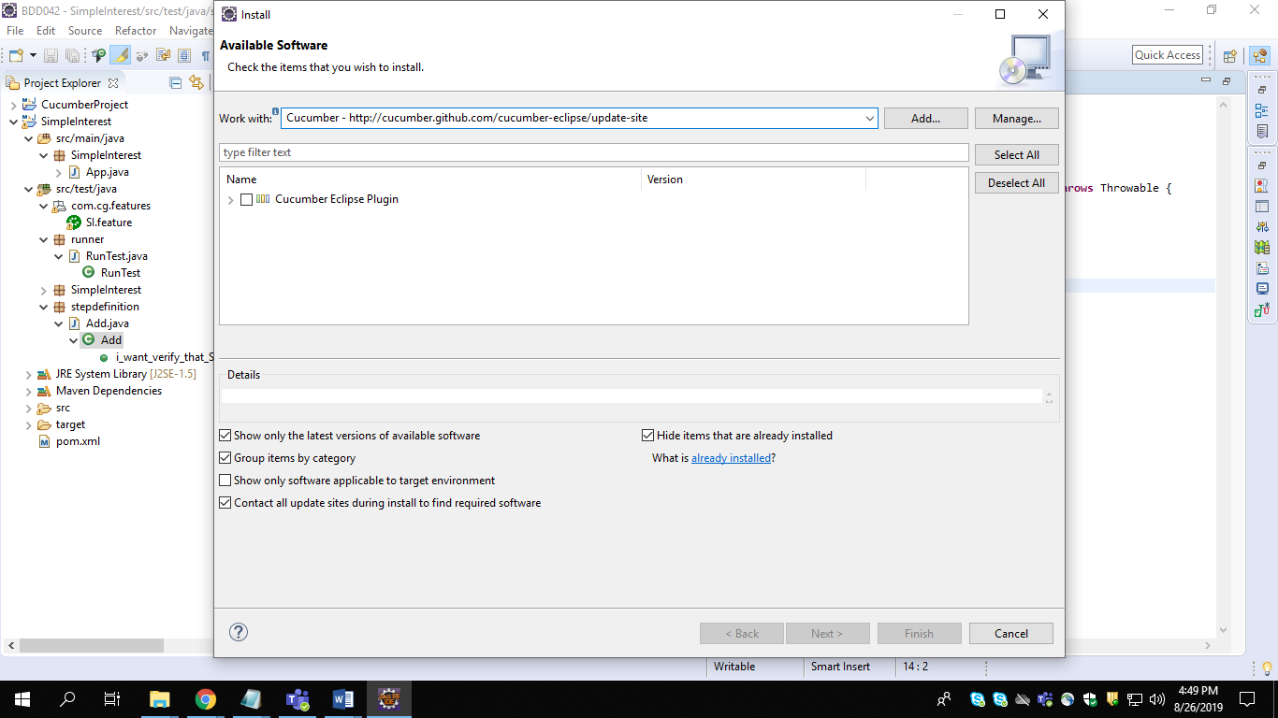

Step: 2

Create a new maven project using eclipse

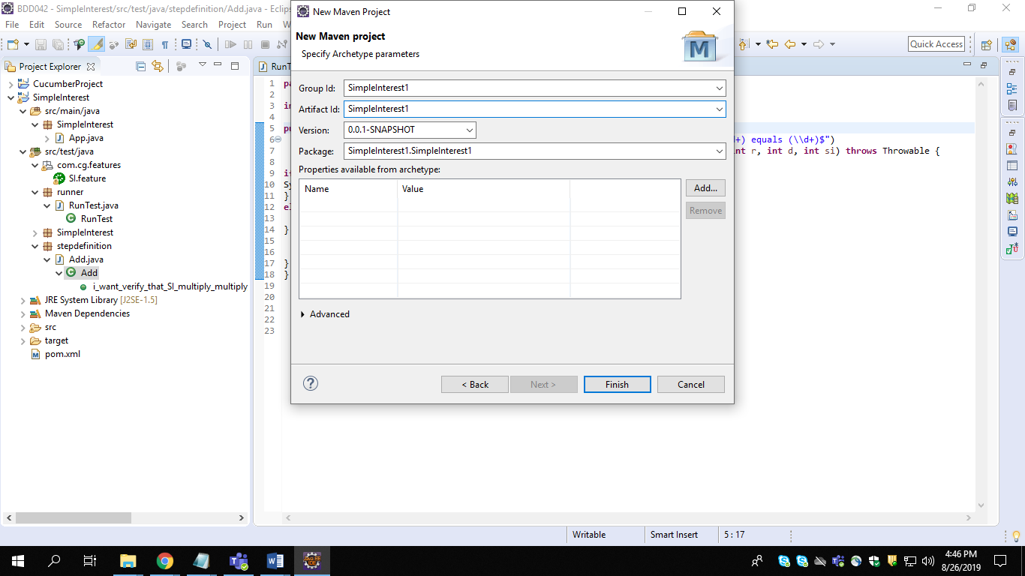Step: 3

Download the dependencies and put in pom.xml

1. J-unit

2. Cucumber-J unit

3. Cucumber-Java

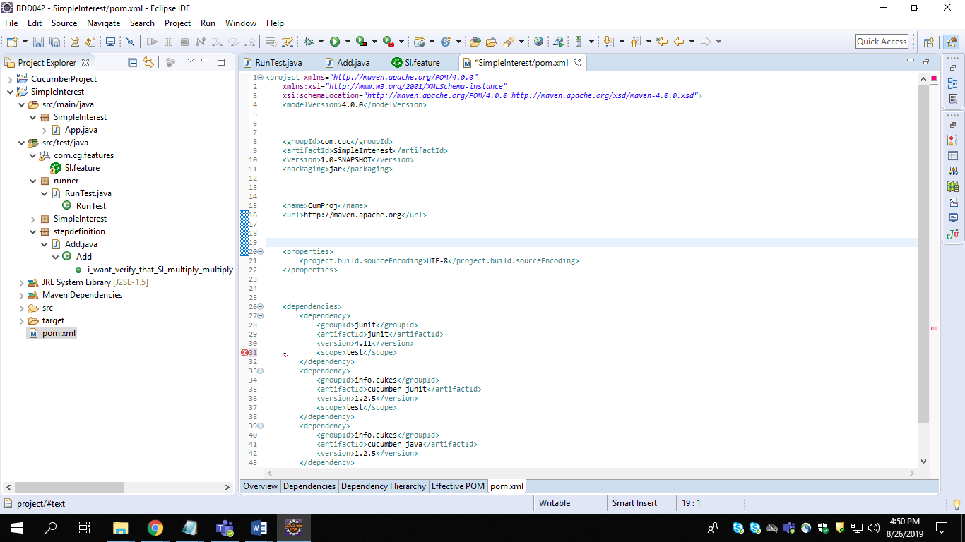

Step: 4

Create a feature file which demonstrates the test cases

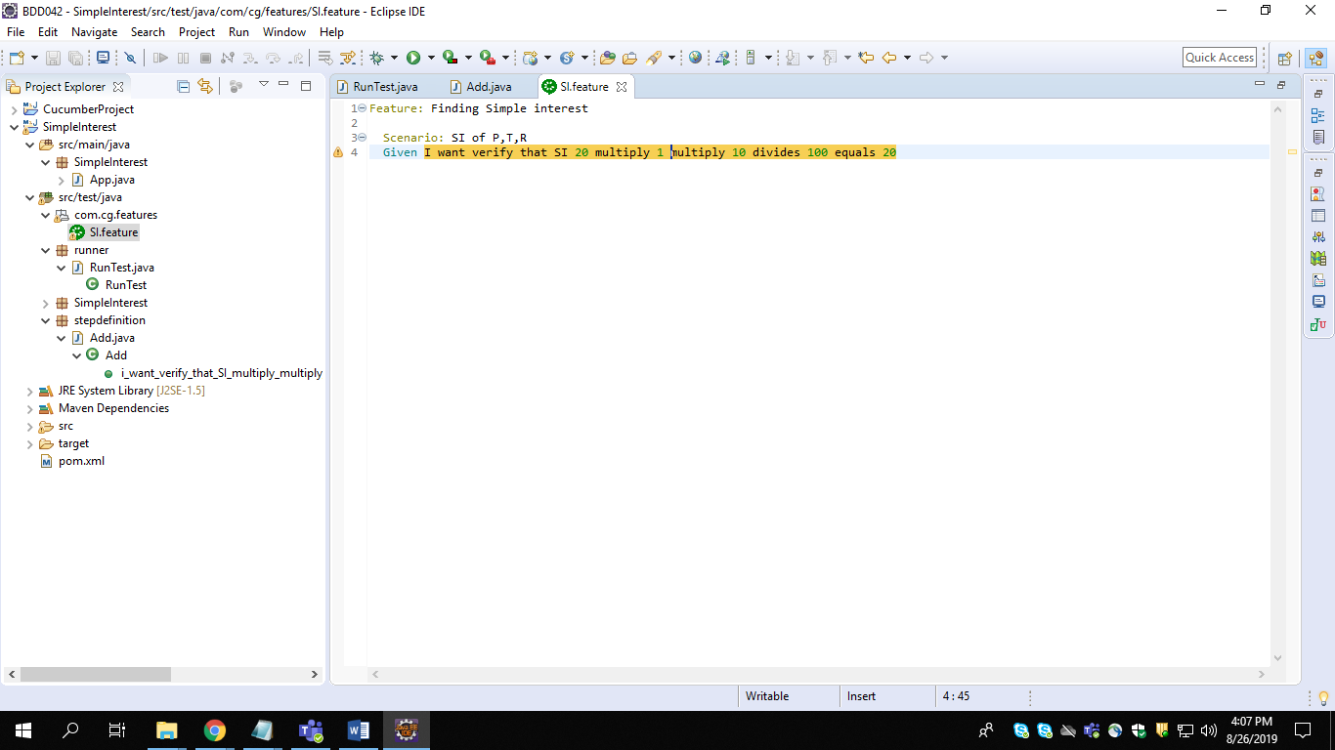

Step: 5

Create a step definition file (java) which is generated by running feature file

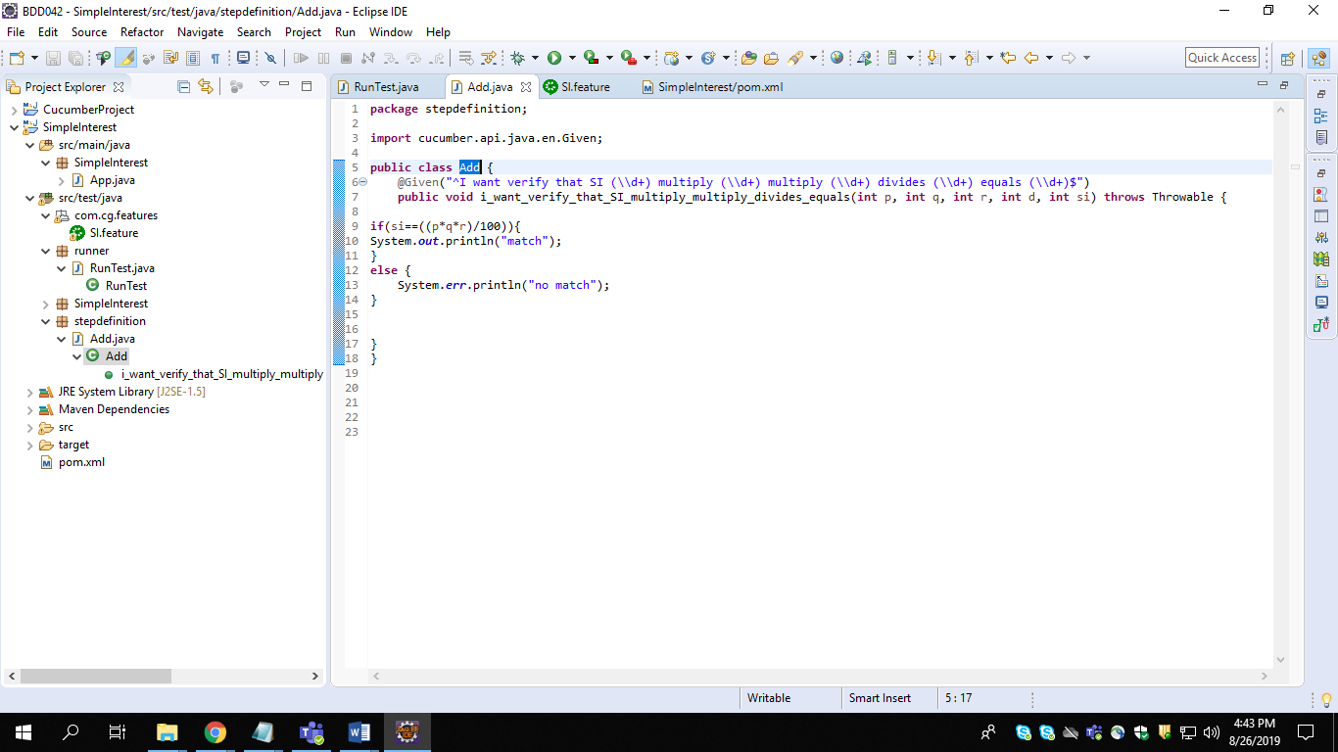

Step: 6

Create a test class (java) which invokes to run the test cases

we should annotate with @CucumberOptions and @Run with

@CucumberOptions(feature,glue,plugin)

@RunWith(Cucumber.class)

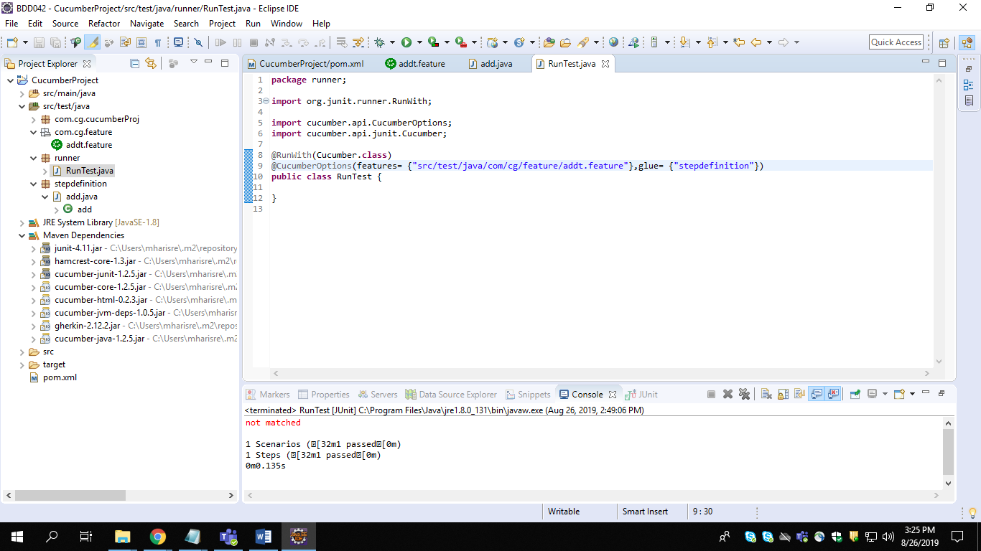

Step: 7

Run the file having test cases (RunTest.java) and the output should be

